ECoG:

Make a folder for each seizure, within a patient’s main folder:

UCSF1_01/UCSF1_01 (other seizures are _02, _03, etc)

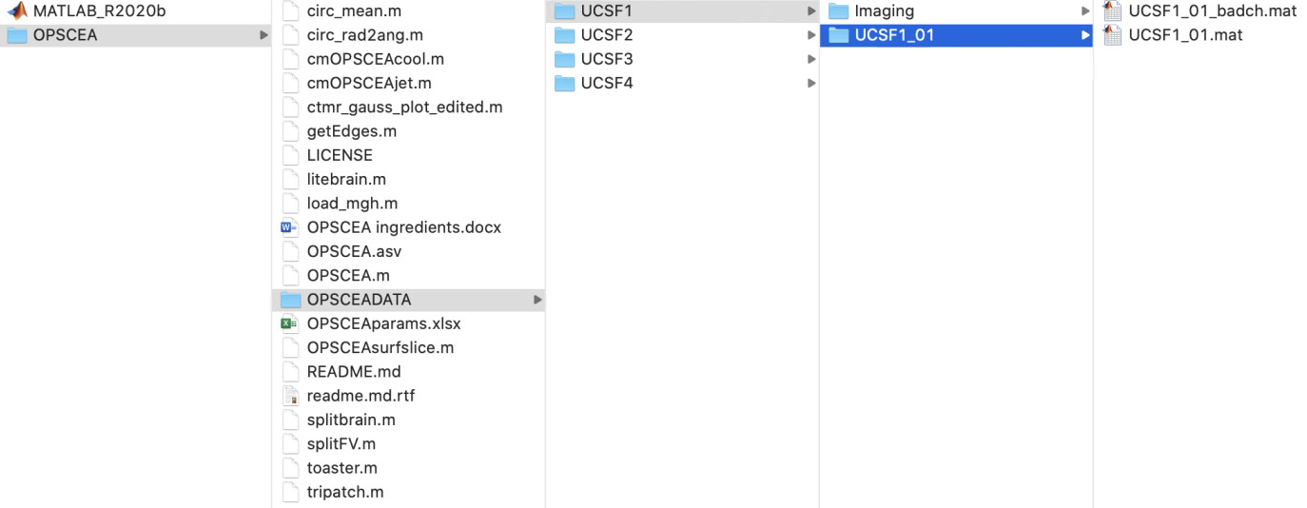

ICEEG data preprocessing steps:

* Process the data: downsample to 512 Hz, notch filter
* Make index of bad channels
* See OPSCEA ingredients help file for additional information

Excel sheet: “OPSCEAparams.xlsx”

* **“params” sheet**: contains every single seizure from every patient as a row, each parameter for video display as a column.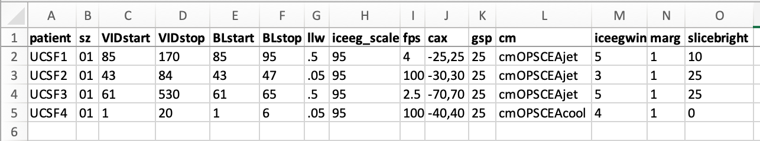
  + Description of each parameter:
    - **patient** = identifier for which patient’s seizure(s) being processed (string, such as ‘UCSF5’)
    - **sz** = number of seizure (string, such as ‘01’)
      * e.g. UCSF5 could have 3 seizures process and make into videos, so this would correspond to 3 rows on params sheet.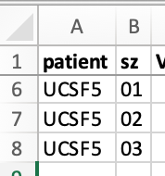
    - **VIDstart** = time in seconds of ICEEG data file to start the video (suggestion: before seizure onset)
    - **VIDstop** = time in seconds of ICEEG data file to stop the video
    - **BLstart** = time in seconds of ICEEG data file to start to use as a “baseline segment” of patient’s brain activity. Needed to calculate gaussian spread of heat map
    - **BLstop** = time in seconds of ICEEG data file to stop “baseline segment”
    - **llw** = length of line length window for ECOG data
    - **iceeg_scale** = scale of ECOG gain displayed in ECOG data
    - **fps** = frames per second of data to capture for video
      * Tip: use a small fps (~0.1) to make a short sample video to make sure your code works.
    - **cax** = values of color axis to control saturation of color on heat map
    - **gsp** = gaussian spreading parameter, how far to project the color from each electrode (spatial extent dropoff).
    - **cm** = color map to determine the spectrum of colors used in heatmap
      * 2 included in github package: cmOPSCEAjet and cmOPSCEAcool
    - **iceegwin** = number of seconds of ECOG data to display per frame
    - **marg** = margin of data to show preceding the line length window (llw) in ECOG display
    - **slicebright** = value brightens up the omniplanar slice for lighting purposes
  + Tip: for each new patient, copy previous row into a new row and replace the seizure start/stop times, and the baseline stretch times. Make adjustments as needed.
* Patient sheets: Make a new sheet by copying an old one. Each row is a separate subplot, so add/remove PRN.
  + Rename it to patient identifier (e.g. UCSF3)
  + Put accurate depth electrode numbers in (from the ***Electrodefile.mat*** file in matlab)
    - For additional depths, just add rows. You’ll need to add colors for them (RGB)
  + Mark the surface views you want, RAI would be a right anterior inferior viewpoint.
  + Adjust all subplots
    - ECoG always goes in the right side, so it would be 5,1,5 for those 3 subplot columns